Portfolio of Crozzle

Task 2

XUN SUN

2016

Content

Introduction 1

Body 2

Section 1 2

Section 2 2

Section 3 2

Appendix 3

# Introduction

This document is a portfolio file for crozzle task 2. There are four parts in this document. First, content part will make reader understand the skeleton of this file. Second, introduction will show the theme of this file and guide reader how to read it. Third, body part will describe the result of three test file running in crozzle program. Finally, appendix will show the screenshot of testing outcomes.

# Body

## Section 1

This section will test with Test 1 – EASY Configuration and Test 1 – EASY in Files for Assessment. During testing, program never crash and it shows the crozzle board and final score, which is shown at Pic 1.1. There are nine words on board, totally fifty one point. Therefore, this program can handle easy crozzle problem.

## Section 2

This section will test with Test 2 – MEDIUM Configuration and Test 2 – MEDIUM in Files for Assessment. During testing, program never crash and it shows the crozzle board with twelve words and 844 points, which is displayed at Pic 2.1. Therefore, this program can solve medium crozzle problem.

## Section 3

This section will test with Test 3 – HARD Configuration and Test 3 – HARD in Files for Assessment. During testing, program never crash and it shows the crozzle board with fourteen words and 528 points, which is demonstrated at Pic 3.1. Therefore, this program can work out hard crozzle problem.

# Appendix

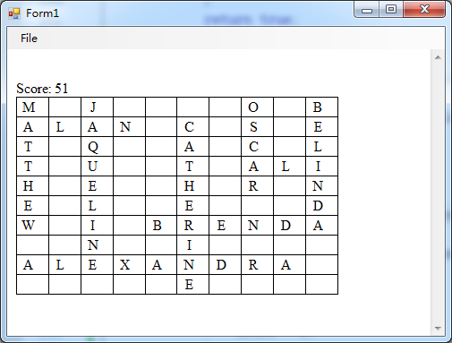

Pic 1.1

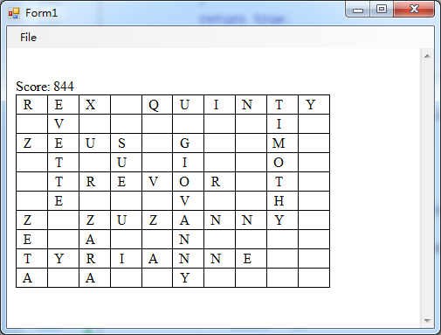

Pic 2.1

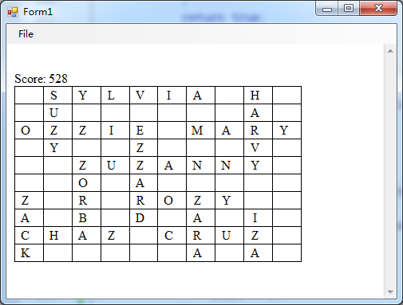

Pic 3.1